CONFIDENTIAL


UNIVERSITI TEKNOLOGI MALAYSIA
FINAL EXAMINATION SEMESTER I , 2016 / 2017

Faculty of Computing

COURSE CODE : SCSR2043 / SCR2043 / SCSS4213

COURSE NAME : OPERATING SYSTEM
SECTION :
TIME :
DATE/DAY :
VENUE :
_____________________________________________________________________________

INSTRUCTIONS :

- This question booklet consists of 2 sections: SECTION A and SECTION B.
- Transfer your SECTION A answer into objective answer form provided in Appendix B.
- Tie together your question booklet and answer booklet using provided thread. Both booklets will be collected at the end of the exam session.

(Please Write Your Lecturer Name And Section In Your Answer Booklet)

Name

I/C No.

Year / Course

Section

Lecturer Name

This question paper consists of SIXTEEN ( 16 ) printed pages excluding this page.

SECTION A
OBJECTIVE QUESTIONS (20 MARKS)
(INSTRUCTION: Please transfer answer of Section A into form provided in Appendix B)

1) _____ is a part of a program that must complete its execution before other process can access the resources being used.

A. Coding
B. Entry section
C. Deadlock
D. Critical section

2) Which of the following locking mechanism type CANNOT be used for critical section solution?

A. Test and set.
B. Peterson.
C. Starvation.
D. Semaphore.

3) All of the following are the requirements for critical section solutions EXCEPT:

A. mutual exclusion.
B. request permission.
C. progress.
D. bounded waiting.

4) What is the condition of variable S for operation wait(S) that implies busy critical section?

A. S = 1
B. S > 1
C. S <= 0
D. S > 0

5) Which of the following event for two processes, P₀ and P₁ is TRUE for Peterson’s algorithm when the turn suddenly changes to 0? Assume initially the flag[0] and flag[1] are FALSE.

A. P₀ is requesting to enter critical section.
B. P₁ is changing it flag[1] to TRUE.
C. P₀ is entering the remainder section.
D. P₁ is changing it flag[1] to FALSE.

6) An operating system often distinguish the _____ with the value of 0 and 1.

A. number semaphore
B. counting semaphore
C. serial semaphore
D. binary semaphore

7) A state when each process in the set of processes waiting for an event that can be caused only
by another process is referred to as _____.

A. deadlock
B. concurrency
C. instances
D. preemption

8) All of the following are the 4 conditions that simultaneously occurring prior to deadlock or
livelock EXCEPT:

A. mutual exclusion.
B. hold and wait.
C. circular wait.
D. preemption.

9) Which memory job allocation technique makes the best use of memory space?

- First fit
- Next fit
- Best fit
- Worst fit

10) Which memory job allocation technique is faster in making allocation?

- First fit
- Next fit
- Best fit
- Worst fit

11) __________ has the largest wasted space and the biggest partition fitting the requirements.

A. Next-fit memory allocation
B. First-fit memory allocation
C. Worst-fit memory allocation
D. Best-fit memory allocation

12) In paging memory management, if the page size is 64 bytes. What is the displacement (or
offset) for logical address 130 of a program on the last page? (Note: 130 is in decimal).

A. 0
B. 2
C. 4
D. 30

13) To access a location in memory when using segmented memory management, the address is
composed of two entries: ____.

A. the segment number and the page number
B. the line number and the displacement
C. the segment number and the displacement
D. the segment number and the subroutine number

14) Which of the following statements regarding page-replacement algorithms is FALSE?

A. Less number of page faults would occur if more frames are available.
B. If the degree of multiprogramming is increased, thrashing might occur and cause the CPU utilization to drops sharply.
C. The working-set model is based on the assumption of locality.
D. The FIFO page replacement algorithm requires that the page with the smallest count to be replaced.

15) Which of the following statements regarding paging memory management is FALSE?

A. Paging table is compulsory.
B. The number of frames must always equal the number of pages.
C. The size of a page must always equal to the size of a frame.
D. Page and frame size are always in power of 2.

16) Using RAID, fast searching is achieved through data ________, while data reliability is
achieved through data _______.

- compression, stripping
- decryption, compression
- stripping, mirroring
- encryption, stripping

17) Which one of the following statements is FALSE regarding File Manager?

- File Manager should provide users with device independent user’s commands.
- File Manager is responsible to perform file error checking.
- File Manager allocates and deallocates files to processes.
- File Manager is the only module that can directly access to files.

18) Which one of the following statements is NOT a goal of disk scheduling algorithms?

- Minimize arm movement.
- Minimize mean response time.
- Maximize size of data read per given amount of time.
- Maximize number of track travelled by the disk head.

19) Total disk access time is given as A = B + C + D. If B is the transfer time of the data, and C is the time of the disk head required to move to a particular cylinder, what is D?

- Data Transfer time.
- Rotational delay.
- Seek Time.
- Communication time.

20) Which one of the following storage allocation scheme is described by these statements?

- Records are stored one after another.
- The scheme has minimum disk access time
- The scheme experiences difficult file expansion and external fragmentation

- Directory Level storage allocation scheme.
- Contiguous storage allocation scheme.
- Multiple Indexed storage allocation scheme.
- Storage Level storage allocation scheme.

SECTION B
STRUCTURED QUESTIONS (80 MARKS)
INSTRUCTION: Answer all questions.
_____________________________________________________________________________
QUESTION 1 [10 MARKS]

(a) In Peterson’s algorithm, assume two processes P₀ and P₁ need to execute their critical section concurrently. Complete Table C1 in Appendix C, with the flag[] status, turn value and events occurred at particular time. Assume the initial value of flag[0] and flag[1] are FALSE. Refer Peterson’s algorithm in Appendix A. [5 Marks]

(b) The following codes shown in Figure 1 consists of 2 semaphore and 2 concurrent processes. Assume that these processes execute for a sufficient long time under a preemptive scheduler. Complete Table C2 in Appendix C by writing the value of S, V and possible output of the printf statement. [5 Marks]

struct semaphore S, V;
A = 2;
B = 0;
//Process 1  while(1) {  wait(S);  printf(“is easy!!! \n”);  signal(V);  } | //Process 2  while(1) {  wait(S);  printf(“Operating ”);  printf(“System \n”);  signal(V);  }

Figure 1

QUESTION 2 [15 MARKS]
(a) Consider a system has a resource A with 12 instances being shared concurrently by 3 processes, P₁, P₂ and P₃. Assume the allocation and maximum need for each process are shown in Table 1. Determine the safe state using the safety algorithm. Justify your answer. [4 Marks]
Table 1
Processes | Allocation | Maximum
P₁ | 5 | 10
P₂ | 2 | 4
P₃ | 3 | 9

(b) Consider a system with 3 processes, P₁, P₂, P₃, and 3 resources type A, B and C with the their instances respectively as shown in Table 2. Assume that the allocation and maximum need for each process at time t₀ are shown in Table 3.
Table 2 |  |  | Table 3
Resource | Total Instances |  |  | Allocation |  |  | Maximum
 |  |  |  | A | B | C | A | B | C
A | 10 |  | P₁ | 3 | 1 | 0 | 7 | 3 | 4
B | 5 |  | P₂ | 2 | 0 | 4 | 5 | 2 | 6
C | 7 |  | P₃ | 1 | 2 | 1 | 8 | 3 | 3

(i) Determine whether the system is in safe or unsafe state. The safety algorithm is provided in Figure A2 of Appendix A. Justify your answer. [7 Marks]
(ii) Suppose at time t₂, P₂ requests for 1 additional instance of resource A and C. Fill Table C3 in Appendix C with the correct value of the matrices. [4 Marks]
QUESTION 3 [15 MARKS]

- Given new jobs, Job 6 until Job 10 in Figure 2, and main memory using dynamic
partitions as shown in Figure 3. Consider Job 1 until Job 5 ends at t₁₀.
Jobs Size  6 100K  7 60K  8 15K  9 10K  10 30K  Figure 2: Job description | 80K Job 1  25K Job 2  25K Job 3  40K Job 4  5K Job 5  Figure 3: Memory partition

- Redraw and label each job that will be allocated into the dynamic partitions after t₁₀. Shades all unused partition clearly. [4 Marks]

- Calculate the total external fragmentation of the memory for case (i). [2 Marks]

- Identify which job has to wait and cannot be allocated into the memory? [1 Mark]

(b) In an operating system, assume memory is allocated as specified in Figure 4.
10K | 10K | 20K | 30K | 10K | 5K | 30K | 20K | 10K | 15K | 25K | 20K

 | Used |  | Hole (Unused)
Figure 4: Partition memory allocation.

- Redraw how the following set of jobs {J1 - 15KB, J2 - 30KB, J3 - 5KB, J4 - 20KB} (in that order) are allocated inside the memory using next-fit allocation. [4 Marks]

- Redraw how the following set of jobs {J1 - 20KB, J2 - 10KB, J3 - 5KB, J4 - 30KB} (in that order) are allocated inside memory using best-fit allocation. [4 marks]
QUESTION 4 [20 MARKS]
(a) Consider a logical-address space of 32 pages of 16 bytes each, mapped onto a physical memory of 1024 frames. [2 Marks]

i. How many bits are in the logical address?
ii. How many bits are in the physical address?

(b) Given a paging system with 2³² bytes of physical memory; 2¹³ pages of logical address space and page size of 4096 bytes.

i. What is the total size of the logical address space. [2 Marks]
ii. What is the frame size of the physical memory. [1 Mark]
iii. How many frames of the physical memory. [1 Mark]
iv. How many number of entries in the page table. [1 Mark]
v. Calculate the offset bits for a page of virtual memory. [1 Mark]
vi. Draw the frame offset of the physical memory address and page offset of logical memory. [2 Marks]

(c) Assume that we have a demand-paged memory. Consider the following page-reference string:
1 | 2 | 3 | 4 | 1 | 3 | 4 | 5 | 4 | 3

- Apply LRU page replacement algorithm and calculate how many page faults will occur. Assume three (3) page frames are used. Show all your workings. [4 Marks]
- Apply OPT page replacement algorithm and calculate how many page faults will occur. Assume three (3) page frames are used. Show all your workings. [4 Marks]

- Which algorithm has the best performance in term of page faults occurred? Justify your answer. [2 Marks]

QUESTION 5 [12 MARKS]

- Figure 5 shows a bit map for free space management for a hypothetical operating system whereby bit 0 indicates that the block is used and bit 1 indicates that the block is free.

Block No | 0 | 1 | 2 | 3 | 4 | 5 | 6 | 7 | 8 | 9 | 10 | 11 | 12 | 13 | 14 | 15
Bit Map | 0 | 1 | 1 | 0 | 1 | 0 | 0 | 1 | 0 | 1 | 1 | 1 | 0 | 1 | 0 | 0

Figure 5: Storage Map

Suppose that the size of a block is 15KB.

- List the block numbers that are allocated to a file named DATA.txt. The size of the DATA.txt is 84 KB. [1 Mark]

- Is there any block that suffers from fragmentation in storing the DATA.txt?
If your answer is a YES, state the block number that contains the fragmentation.
[1 Mark]

- Assuming a disk with capacity of 600KB. The disk has 30 storage blocks and size of each storage block is 20KB. The file that will be stored in the storage disk is File1. Size of File1 is 98KB.

- Assuming the operating system is using Storage Level Non-contiguous Storage Allocation. In Appendix D page:

  - Complete the Directory file. [2 Marks]

  - Update the Storage Map as shown in Appendix D accordingly to show where File1 is stored. Consider the first block for File1 is Block 18. If additional storage block is needed, you may use any empty block as a new data block. [3 Marks]

- Assuming the operating system is using Indexed Storage Allocation. In Appendix E page:

  - Complete the Index file. [2 Marks]

  - Update the Storage Map as shown in Appendix E accordingly to show where File1 is stored. Consider Index block for File1 is Block 3. If additional storage block is needed, you may use any empty block as a new data block. [3 Marks]

QUESTION 6 [8 MARKS]

On a disk with 800 tracks, numbered from 0 to 799, the disk head is currently serving at cylinder 600. The disk queue contains the following track requests:

203, 95, 780, 300, 650, 150

Starting from the current disk head position:

- Draw the head movement to serve the entire request in the disk queue with Shortest Seek Time First (SSTF) algorithm. [3 Marks]

- Draw the head movement to serve all requests in the disk queue with C-SCAN scheduling algorithm. [3 Marks]

c) Based on your answer in (a) and (b) above, determine which algorithm is better? Justify your answer. [2 mark]

APPENDIX A

do {
flag[i] = TRUE;
turn = j;
while (flag[j] && turn == j)
; /* do nothing */
critical section
flag[i] = FALSE;
remainder section
} while (TRUE);

Figure A1: Peterson’s algorithm.

1. Work = Available
Finish[i] = false
2. Find an index i such that both
Finish[i] = false
Need_{i} <= Work
3. Work = Work + Allocation_{i}
Finish [i] = true
Goto Step 2
4. If Finish[i] = true for all i 🡪 safe

Figure A2: Safety algorithm.

APPENDIX B: OBJECTIVE ANSWER SHEET
Name
I/C No.
Lecturer (Circle) | FIROZ | ISMAIL FAUZI | MUHALIM

SECTION A
Mark your answer clearly.
Example: =A= =B= =C= =D=

1. | =A= =B= =C= =D= |  | 11 | =A= =B= =C= =D=
2. | =A= =B= =C= =D= |  | 12. | =A= =B= =C= =D=
3. | =A= =B= =C= =D= |  | 13. | =A= =B= =C= =D=
4. | =A= =B= =C= =D= |  | 14. | =A= =B= =C= =D=
5. | =A= =B= =C= =D= |  | 15. | =A= =B= =C= =D=
6. | =A= =B= =C= =D= |  | 16. | =A= =B= =C= =D=
7. | =A= =B= =C= =D= |  | 17. | =A= =B= =C= =D=
8. | =A= =B= =C= =D= |  | 18. | =A= =B= =C= =D=
9. | =A= =B= =C= =D= |  | 19. | =A= =B= =C= =D=
10. | =A= =B= =C= =D= |  | 20. | =A= =B= =C= =D=

APPENDIX C

Name
I/C No.
Lecturer (Circle) | FIROZ | ISMAIL FAUZI | MUHALIM

Table C1
Time | flag[0] | flag[1] | turn | Events
t₀ |  |  |  | P₀ request to enter CS₀
t₁ |  |  | 1 | P₀
t₂ | TRUE |  | 0 | P₁
t₃ | FALSE |  |  | P₀
t₄ |  |  | 0 | P₁ enter CS₁
t₅ | TRUE | TRUE |  | P₀

Table C2
Processes | S | V | Output
(initial) | 2 | 0 | -
Table C3
Request(P₂)
Available
Allocation(P₂)
Need(P₂)

APPENDIX D

Name
I/C No.
Lecturer (Circle) | FIROZ | ISMAIL FAUZI | MUHALIM

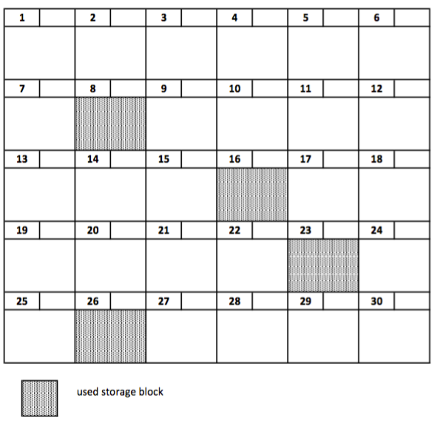

Directory File
File No. | Start | End | Number of Extents

APPENDIX E

Name
I/C No.
Lecturer (Circle) | FIROZ | ISMAIL FAUZI | MUHALIM

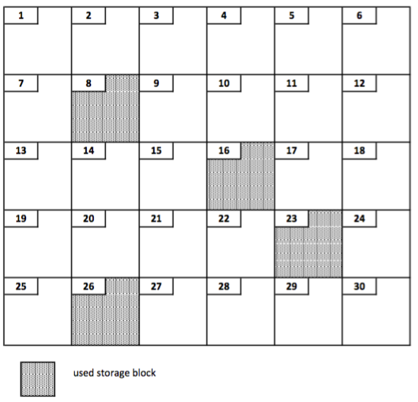

Index
File No. | Index Block

